**AI-Powered Business Intelligence System Proposal**

**Prepared for:** **Magnate Ventures Limited**

**Prepared by:** **Peter Kinyanjui Kaheni**

**Date:** **12th** **August 2025**

**1. Executive Summary**

This proposal outlines an AI-powered system designed to optimize Magnate’s advertising campaigns and streamline operational workflows. The solution integrates **Dynamic Creative Selection**, **AI-Driven Scheduling**, and **Automated OCR Processing** into a unified platform. The aim is to boost marketing ROI, improve operational efficiency, and enhance decision-making with minimal manual intervention.

### ****2. System Overview****

The proposed system consists of **three core modules**, each targeting a specific business challenge:

1. **Dynamic Creative Selector** – Optimizes ad creative selection to maximize engagement.
2. **Greedy Scheduler** – Efficiently schedules campaigns based on priority, availability, and performance.
3. **OCR Demo** – Automates extraction of key information from invoices and purchase orders.

These modules work independently but can be integrated into Magnate’s existing campaign management and operational systems.

### ****3. Detailed Module Descriptions****

#### **3.1 Dynamic Creative Selector**

**Purpose:**  
Automatically selects the highest-performing creative for a given campaign and audience context, using AI-driven prediction models.

**How It Works:**

* The user uploads or lists multiple creatives (images, videos, banners).
* The system evaluates past performance data, audience preferences, and contextual factors (e.g., time of day, platform type).
* The top-performing creative is selected in real time and pushed for deployment.

**Key Benefits for Magnate:**

* Improves campaign ROI by delivering the right message to the right audience.
* Reduces manual A/B testing time.
* Increases engagement rates with data-backed decisions.

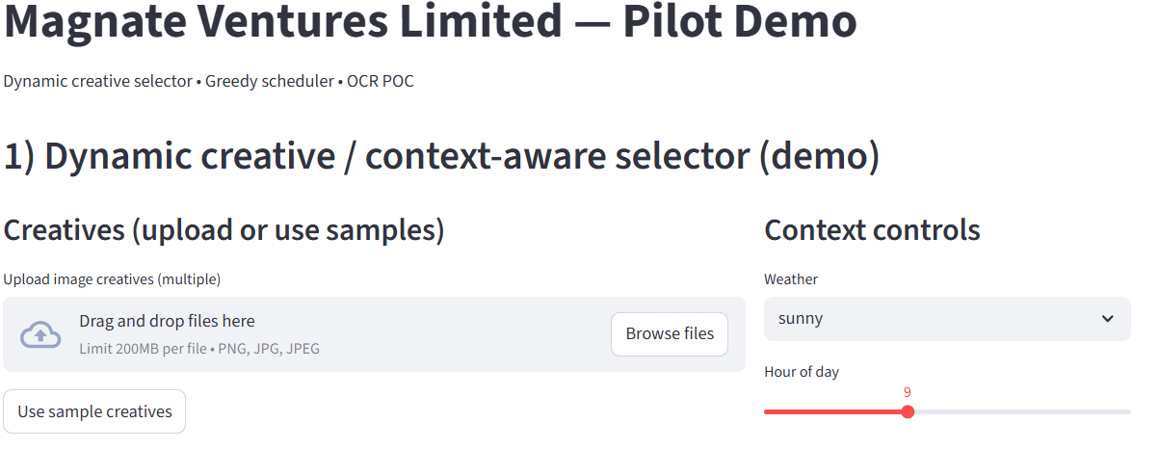

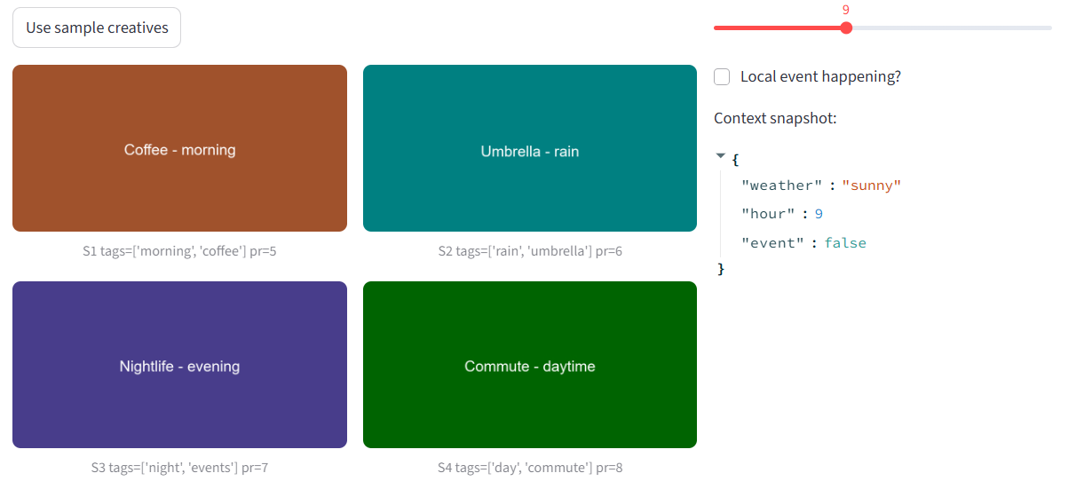

#### **3.2 Greedy Scheduler**

**Purpose:**  
Optimally schedules campaigns into available time slots to ensure maximum efficiency and visibility.

**How It Works:**

* Users input campaigns and their requirements (priority, duration, constraints).
* The greedy scheduling algorithm allocates campaigns to slots that maximize value without overlaps.
* Results are displayed in a clear, visual timetable.

**Key Benefits for Magnate:**

* Maximizes ad inventory utilization.
* Prevents scheduling conflicts.
* Simplifies complex scheduling into a one-click operation.

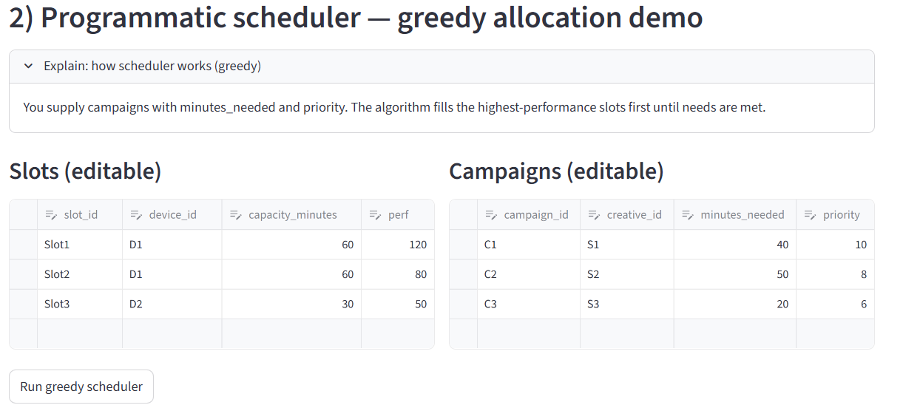

#### **3.3 OCR Demo**

**Purpose:**  
Automates the reading and processing of invoice and purchase order documents to reduce manual data entry and errors.

**How It Works:**

* Users upload scanned invoices or POs.
* The OCR engine extracts relevant fields (e.g., invoice number, vendor name, amount, date).
* Extracted data is displayed, verified, and exported for further use.

**Key Benefits for Magnate:**

* Cuts down manual data entry time.
* Reduces human error in financial operations.
* Accelerates document processing and record-keeping.

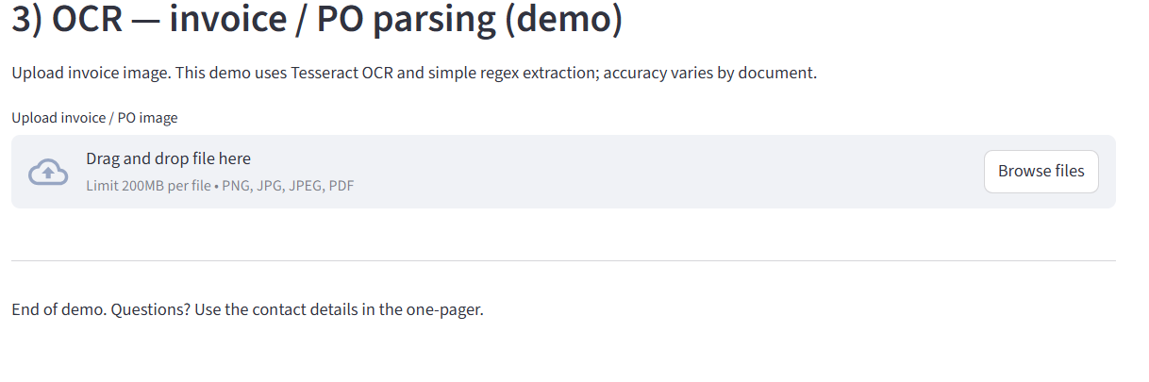

## **4. Implementation Plan**

* **Phase 1:** Requirements gathering & system design.
* **Phase 2:** Development of Greedy Scheduler & OCR modules.
* **Phase 3:** Integration with Magnate’s systems.
* **Phase 4:** Testing & training of staff.
* **Phase 5:** Deployment & performance monitoring.

## **6. Technical Details**

* **Tech Stack:** Python, Streamlit, OCR libraries (Tesseract), scheduling algorithms.
* **Data Handling:** Secure upload and processing, encryption for sensitive invoice data.
* **Integration Points:** Ad management systems, CRM, financial software.

## **7. Expected Benefits**

* 60%+ reduction in scheduling time.
* 70%+ reduction in document entry time.
* Improved ad slot utilization and campaign ROI.
* Reduced human error.

**8. Conclusion**  
Adopting this solution will streamline operations, reduce manual inefficiencies, and enable faster, data-driven decision-making. By delivering personalized and timely client experiences, it will boost satisfaction, strengthen loyalty, and create a competitive edge. Ultimately, these improvements will drive consistent revenue growth and optimize resource utilization.